MAKE THE GRADE
QUESTIONS
1 - 9

ALGEBRA

  - Find the equation of the line passing through (6,5) and perpendicular to the line y = 3x + 4.

(4)

  - Rearrange the following expressions in descending order if:
$$a^{\text{-2}}{\text{ a}}^{\frac{1}{2}}{\text{ a}}^{\text{0 }}{\text{ a}}^{−\frac{1}{2}}$$

- a = 16

(5)
- a = $\frac{1}{\text{81}}$

(5)

  - Make t the subject of the formula in each case:

i) $P=\frac{4}{t}$

(1)
ii) $W=\frac{2+3t}{t}$

(3)
iii) $F=\frac{s\text{-t}}{t}$

(3)

  - The volume of a splogoid is directly proportional to the cube of the diameter
When the volume is 324cm³, the diameter is 6cm.

- Find a formula for the volume of a splogoid, V, in terms of the diameter, d.

(2)

ii) Find the diameter of a splogoid with volume 12cm³

(2)
  - w is inversely proportional to the positive square root of t.
When w = 5, k = 100

- Find a formula linking w and k

(2)

- Using your formula find:

  - w when t = $\frac{1}{4}$

b) k when w = 10

(4)

6. Prove that the sum of three consecutive numbers is always a multiple of 3.

(4)
7. The graph of y = x² + 2x – 8 is shown below:

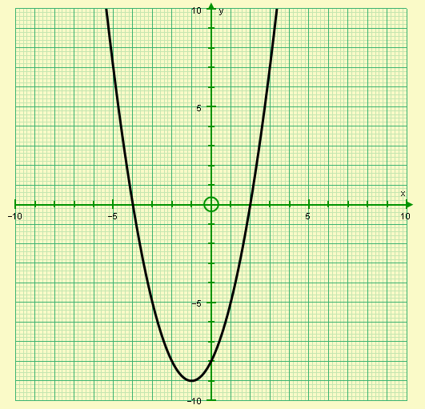

Use the graph to solve the following equations:

- x² + 2x – 8 = 0

- x² + 2x – 8 = -4

- x² + 2x – 10 = 0

- x² + 2x – 8 = x

- x² + x – 3 = 0

(17)

- Factorise the following:

- x² - 36 =

- 2a² - 50 = 2(a²-25)

- 4s² - 9t² =

- 2x² + 7x + 3 =

- 3y² + y - 4 =

vi) 5x² - 11x +2 =

(21)

9. i) Simplify $\frac{4}{x}+\frac{6}{x+2}$

(4)

ii) Hence, or otherwise, solve $\frac{4}{x}\text{ + }\frac{6}{\text{x+2}}\text{=2}$

(5)

- Solve the following, giving your answers to 1 decimal place.

- x² + 5x + 1 = 0
CALCULATORS ARE NOW ALLOWED

- y² -10y +4 = 0

- 2x² +13x – 5 = 2

(15)
- Meryl is solving the quadratic equation 2x² - 10x – 8 = 0 using the quadratic formula.
The first part of her solution is shown below:

$$x=\frac{\text{-10 }±\sqrt{{\text{-10}}^{2}−4×2×−8}}{2}=\frac{−\text{10}±\sqrt{\text{-100-64}}}{2}$$

Find four mistakes with Meryl’s solution.

(4)
- Solve the following by completing the square, giving your answers to 1 decimal place.
- x² + 6x + 2 = 0

- y² + y – 1 = 0

(10)
13.
4
3x + 2
A
2x - 4
B

2x + 4

a) Show that the area of the shape is given by the expression 6x² +12x – 16.

(3)

b) If the area of the shape is 20cm², find the length of the longest side.

(5)

- Match the quadratic function to the correct graph, giving reasons for your answer.
y= x² + 8x + 16y = x² - 6x + 16

y = x² + 10x + 16 y = x² - 9x + 16

y

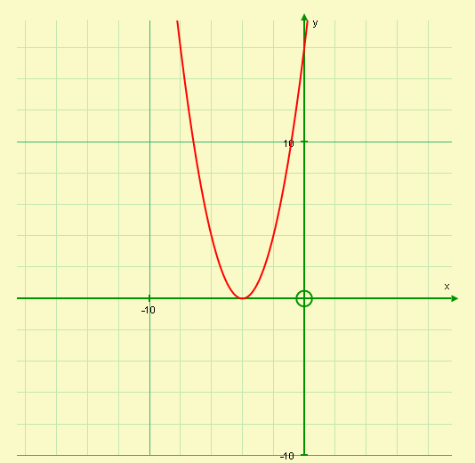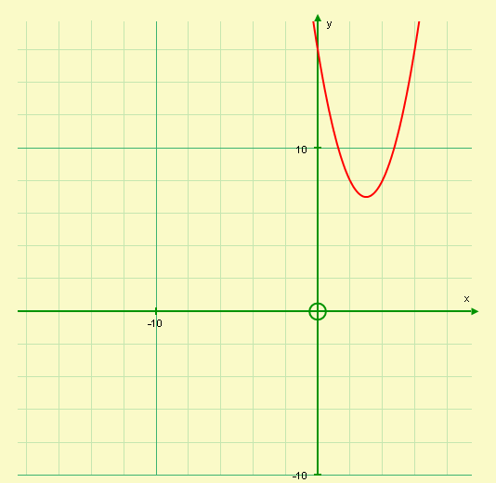
Equation:

Reason:
Equation:

Reason:

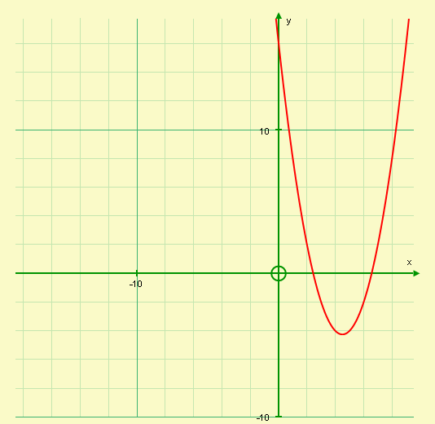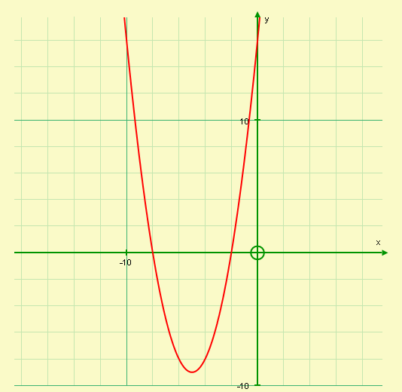
Equation:

Reason:
Equation:

Reason:

(12)
Did you ‘Make the Grade’?
Skill | Qu | ☺ | ☹
I can find the equation of a perpendicular line | 1
I can evaluate algebraic expressions involving negative and fractional powers | 2
I can rearrange more complex formulae including when variables are given twice | 3
I can solve direct proportion problems | 4
I can solve inverse proportion problems | 5
I can prove simple statements | 6
I can solve quadratic equations graphically | 7
I can factorise quadratics using the difference of two square | 8 i,ii,iii
I can factorise harder quadratics (a>1) | 8 iv, v, vi
I can simplify and solve simple equations involving algebraic fractions | 9
I can solve quadratic equations using the quadratic formula | 10,11,13
I can solve simple quadratic equations using completing the square | 12,(13)
I can sketch the graphs of quadratic functions of the form y = x²+ bx + c | 14

☺ Yippee!! - I got all the questions correct.
☹ I made mistakes and need to practise this topic more.

Top 3 topics I need to revise are

If your score is:

91 - 130 - Well done. You are definitely working at grade A with your algebra skills. Bring on the A*!

45 –90 - Promising work – make sure you ask for help and revise the topics that you had difficulty with. You can still get that A !!!

0 – 45 - Serious revision and help is needed if you are going to get that A. Sort it out now. Don’t wait any longer

