MAKE THE GRADE

ALGEBRA

1 Simplify the following:

a) 24k⁶ c) (2y³)²
6k²

b) 8h⁴ 5h² d) $3a^{2}b^{4}×7{\text{ab}}^{3}$
4h⁵

(12)

- Expand and simplify:

a) (y +2)(y + 6) d) (x – 1)²

(3) (3)

b) (x -3)(x + 4) e) (2m + n)(3m - 2n)

(3) (4)

c) (p – 5)(p – 2)

(3)
- Solve the following equations:

a) $\frac{4+2p}{6}=2$

(3)
b) $\frac{2y}{3}+6=2$

(3)

c) $\frac{5+4m}{4}=\frac{4\text{-m}−}{2}$

(4)
- Solve the following pairs of simultaneous equations:

  - 3x + y = 26 b) 4p – 2q = 20
x + y = 10 p – 2q = 2

x = ……………. p =…………….

y = …………… q =…………….
(3) (3)

- 5x + y = 24 d) 3x – 3y = 24
2x + 2y = 8 x – 2y = 9

x = ……………. x = …………….

y = ……………. y = …………….
(4) (4)

- The graph of y=5x - 4 is shown below:

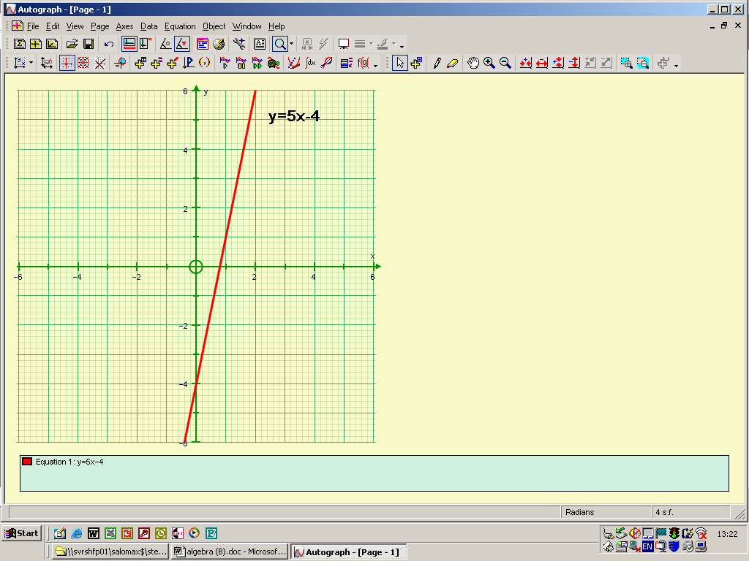

  - On the same axes, draw the graph of x + y = 5 (2)

  - Using the graphs, find the solution of the simultaneous equations:
y=5x – 4
x + y = 5 (2)

6.
A
y = 2x + 6
B
y = 3 – 2x
C
2y = 4x + 6
D
y = 2 + 4x

Using the equations of the graphs in the four boxes given above:

- Write down two graphs that are parallel to each other

- Write down two graphs that cross the y-axis at the same point.

- Write down any graphs that go through the point (2,10)

- Write down any graphs that cross the x-axis at x = -3. (6)

- Find the equation of the line parallel to the line y = 4 + 3x and passing through the point (-4,-1)

(4)

8. Find the equation of the line that passes through the points (1,-1) and (3,3).

(5)

  - Match the equations with the correct graph using the list below
Note: You will have to find a missing equation and complete the blank graph.

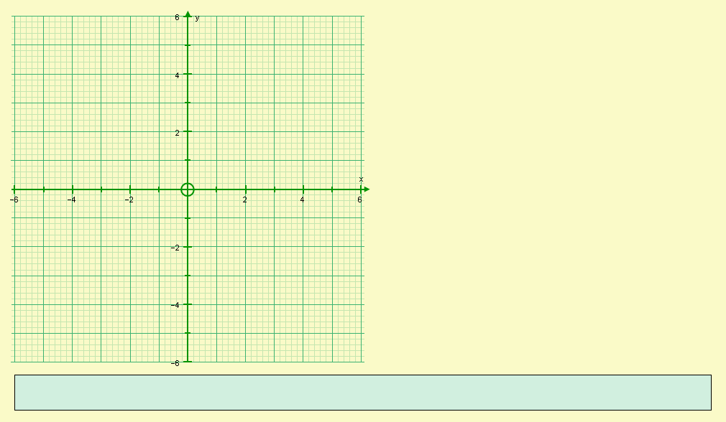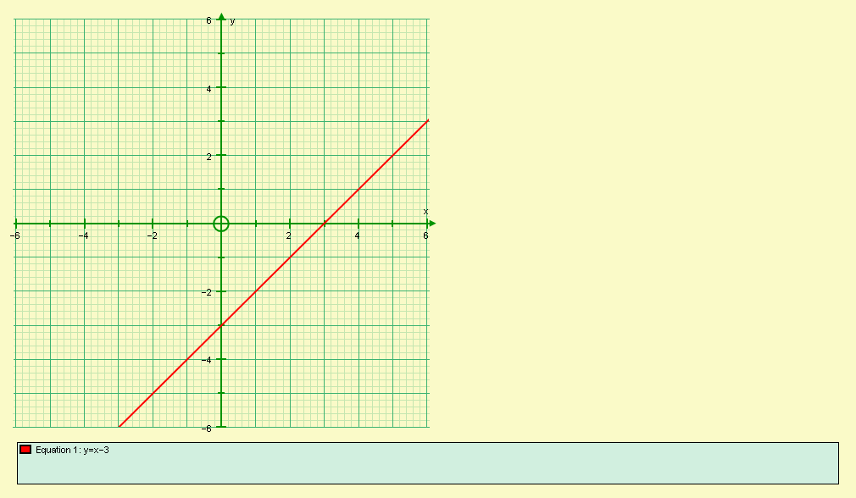

Equation: Equation:

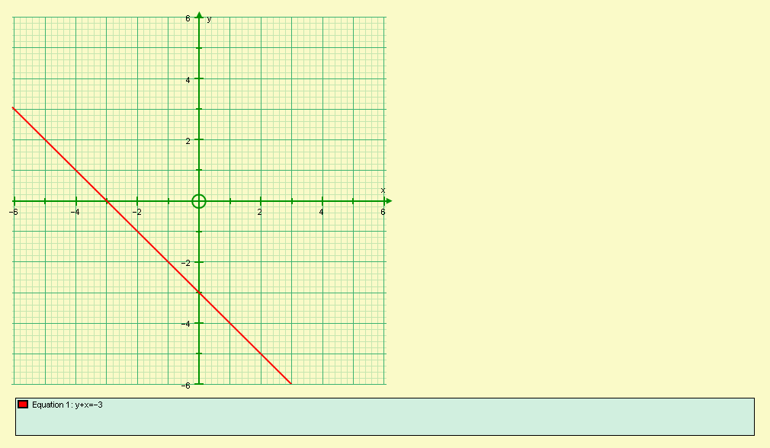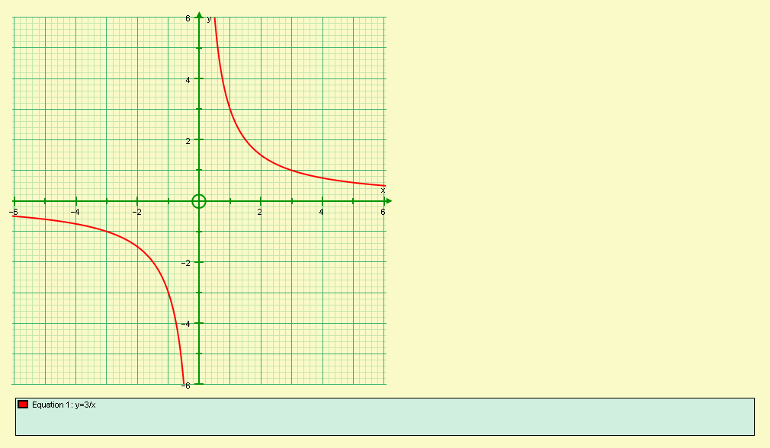

Equation: Equation:
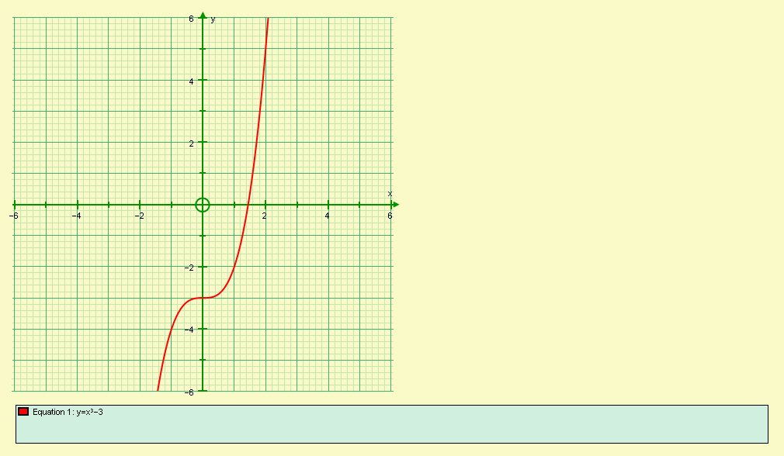

Equation: (6)

  - Solve 4x – 5 7 – 2x

(2)

Show your answer on the number line below:

(2)

- a) On the axes below, mark the region R that satisfies the inequalities:

x < 2 y ≥ 1 y ≤ x + 3 x + y < 4

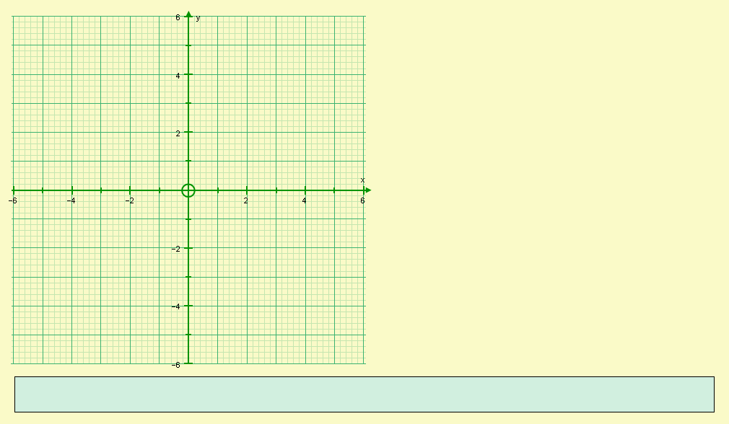

(6)

- Write down the integer co-ordinate pairs that lie within R
(2)

- a) Complete the table of values for y = x³ + 3x² – 3.

X | -3 | -2 | -1 | 0 | 1
y |  | 1 |  |  | 1
(3)

- Draw the graph of y = x³ + 3x² – 3

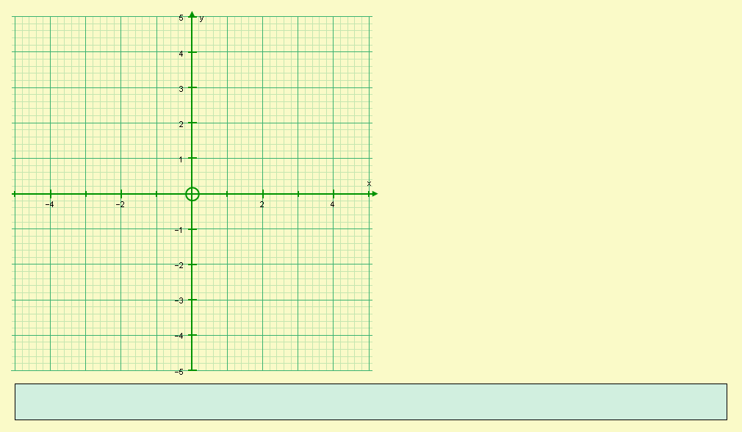

(3)

- Using your graph, or otherwise, solve:
- x³ + 3x² – 3 = 0

ii) x³ + 3x² – 3 = 4

(4)
13. Make t the subject of the equation in the following:

a) $v=\frac{t}{2}+s$

(2)

b) $R=\sqrt{\frac{t}{b}}$

(2)

  - Factorise completely:

- 3pq + 2p² ii) 4st – 14t³

(4)
15. Factorise completely:

- x² + 5x + 6 iv) p² - 9p + 20

    - x² + 2x – 8 v) t² - 49

    - y² - y – 12

(15)

      - a) Factorise x² - y²

(2)

b) Hence, or otherwise, evaluate:

53² - 47²

(2)
      - Simplify:
a) $\frac{3(x+1)^{2}}{x+1}$ b) $\frac{x^{2}+5x+4}{x+1}$

(1) (3)

18. Solve x² + 13x + 12 = 0

(4)

19.
x + 5
x -2

- Write down an expression for the area, A, of the rectangle in terms of x.

(2)
- If A = 18cm², find the longest side of the rectangle.

(5)

Did you ‘Make the Grade’?
Skill | Qu | ☺ | ☹
I can simplify involving indices expressions | 1
I can expand two linear brackets | 2
I can expand and simplify two linear brackets | 2
I can solve linear equations involving fractions | 3
I can solve simple simultaneous equations algebraically | 4a,b
I can solve more complex simultaneous equations algebraically | 4c,d
I can draw the graph of a linear equation | 5a, 9,11a
I can solve simultaneous equations graphically | 5b
I can interpret the equation of a straight line, y=mx+c | 6
I can find the equation of a straight line y=mx+c | 7,8
I can identify linear, quadratic, cubic and reciprocal graphs | 9
I can solve inequalities with unknowns on both sides | 10
I can solve inequalities graphically | 11
I can complete tables of values and draw graphs of cubics | 12a,b
I can solve cubic equations graphically | 12c
I can change the subject of harder fomulae | 13
I can factorise simple expressions | 14
I can factorise quadratics | 15i - iv
I can identify, factorise and use the difference of two squares | 15v, 16a,b
I can use factorizing to simplify algebraic fraction | 17
I can solve quadratic equations | 18
I can form and solve quadratic equations | 19

☺ Yippee!! - I got all the questions correct.
☹ I made mistakes and need to practise this topic more.

Top 3 topics I need to revise are

If your score is:
100 - 144 - Well done. You are working at grade B with your algebra skills.
50 - 99 - Promising work – make sure you ask for help and revise the topics that you had difficulty with. You can still get that B!!!
0 – 49 - Serious revision and help is needed if you are going to get
that B. Sort it out now. Don’t wait any longer

