MAKE THE GRADE

ANSWERS ❶ = 1 mark
ALGEBRA

1 Simplify the following:
❶
❶
❶
❶

a) 24k⁶ $=4k^{4}$ c) (2y³)² $=4y^{6}$
6k²

❶
❶
❶
❶
❶
❶
b) 8h⁴ 5h² $=\frac{\text{40}h^{6}}{4h^{5}}=\text{10}h$ d) $3a^{2}b^{4}×7{\text{ab}}^{3}$$=\text{21}a^{3}b^{7}$
❶
4h⁵

(12)
- Expand and simplify:

a) (y +2)(y + 6) d) (x – 1)² = (x - 1)(x - 1)

 | y | +2
y | y² | +2y
+6 | +6y | +12
 | x | -1
x | x² | -x
-1 | -x | +1
= y² + 2y + 6y + 12 = x² - x – x + 1
= y² + 8y + 12 = x² - 2x + 1
❶
❶
❶
❶
❶
❶
(3) (3)
b) (x -3)(x + 4) e) (2m + n)(3m - 2n)

 | x | -3
x | x² | -3x
+4 | +4x | -12
 | 2m | +n
3m | 6m² | +3mn
-2n | -4mn | -2n²
= x² - 3x + 4x - 12 = 6m² + 3mn – 4mn - 2n²
= x² + x – 12 = 6m² - mn – 2n²
❶
❶
❶
❶
❶
❶
❶
(3) (4)
c) (p – 5)(p – 2)

 | p | -5
p | p² | -5p
-2 | -2p | +10

= p² - 5p – 2p + 10
= p² - 7p + 10 (3)
❶
❶
❶

- Solve the following equations:

a) $\frac{4+2p}{6}=2$
❶
$\begin{aligned}4+2p=\text{12} (\text{x6}) \\ \text{2p }=\text{ 8 }(\text{-4}) \\ p=\text{4 }(÷2)\end{aligned}$
❶
❶
(3)
b) $\frac{2y}{3}+6=2$
$$\begin{aligned}\frac{2y}{3}=\text{-4 }(\text{-6}) \\ \text{2y }=\text{ 12 }(\text{x3}) \\ y=\text{6 }(÷2)\end{aligned}$$
❶
❶
❶

(3)

c) $\frac{5+4m}{4}=\frac{4\text{-m}−}{2}$

$$\begin{aligned}2(5+4m)=4(\text{4-m}) \\ \text{10}+\text{8m}=\text{16-4m } \\ \text{10}+\text{12m}=\text{16 }(+\text{4m}) \\ \text{12m}=\text{6 }(\text{-10}) \\ m=\frac{6}{\text{12}}=\frac{1}{2} (÷\text{12})\end{aligned}$$
❶
❶
❶
❶
(4)
- Solve the following pairs of simultaneous equations:

  - 3x + y = 26 ① b) 4p – 2q = 20 ①
x + y = 10 ② p – 2q = 2 ②
❶
❶
①-②: 2x = 16 ①-②: 3p = 18
x = 8 (÷2) p = 6 (÷3)

Sub x=8 in ②: 8 + y = 10 Sub p=6 in ②: 6 – 2q = 2
y = 2 (-8) 6 = 2 + 2q
4 = 2q
(÷2) 2 = q
Check in ①: (3x8) + 2 = 26☺
Check in ①: (4x6) – (2x2) = 20☺
❶
❶
x = ……8………. p =……6……….
❶
❶
y = … ..2……… q =……2……….
(3) (3)

- 5x + y = 24 ① d) 3x – 3y = 24 ①
2x + 2y = 8 ② x – 2y = 9 ②
❶
❶
①x2: 10x + 2y = 48 ③ ②x3: 3x – 6y = 27 ③
❶
❶
③ - ②: 8x = 40 ① - ③: 3y = -3 x = 5 (÷8) y = -1 (÷3)

Sub x=5 in ①: 25 + y = 24 Sub y=-1 in ②: x – (2x-1) = 9
y = -1 (- 25) x + 2 = 9
x = 7 (-2)
Check in ②: (2x5) + (2x-1) = 8 ☺
Check in ①: (3x7) – (3x-1) = 21+3=24

❶
❶
x = ……5………. x = ……7……….
❶
❶
y = ……-1………. y = …-1……….
(4) (4)

- The graph of y=5x - 4 is shown below:

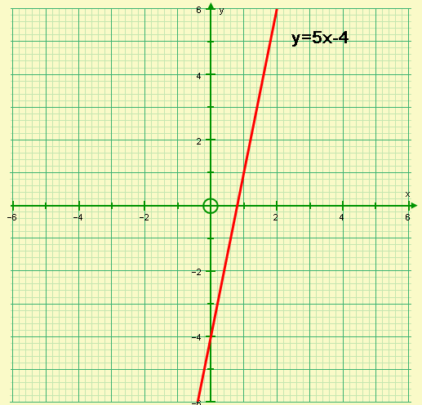
x + y = 5
❶ correct line
❶ label

  - On the same axes, draw the graph of x + y = 5 (2)

  - Using the graphs, find the solution of the simultaneous equations:
y=5x – 4
$$x=1\frac{1}{2}\text{ y}=3\frac{1}{2}$$
x + y = 5 (2)
❶
❶

6.
A
y = 2x + 6
B
y = 3 – 2x
C
2y = 4x + 6
D
y = 2 + 4x

Using the equations of the graphs in the four boxes given above:

- Write down two graphs that are parallel to each other
A and C (Gradient = 2)
❶
❶

- Write down two graphs that cross the y-axis at the same point.
B and C (y=3)
❶
❶

- Write down any graphs that go through the point (2,10)
A and D
❶
❶

- Write down any graphs that cross the x-axis at x = -3. (7)
❶
A

- Find the equation of the line parallel to the line y = 4 + 3x and passing through the point (-4,-1)
❶
Gradient = 3
❶
y = 3x + c

When x = -4, y = -1: -1 = (3 x -4) + c
-1 = -12 +c
❶
11 = c
❶
y = 3x + 11

(4)

8. Find the equation of the line that passes through the points (1,-1) and (3,3).

$\text{Gradient}=\frac{3−(−1)}{3−1}=\frac{4}{2}=2$ ❷
❶
y = 2x + c

When x = 3, y = 3: 3 = (2 x 3) + c
3 = 6 + c
❶
-3 = c
❶
y = 2x - 3

(5)

  - Match the equations with the correct graph using the list below
Note: You will have to find a missing equation and complete the blank graph.

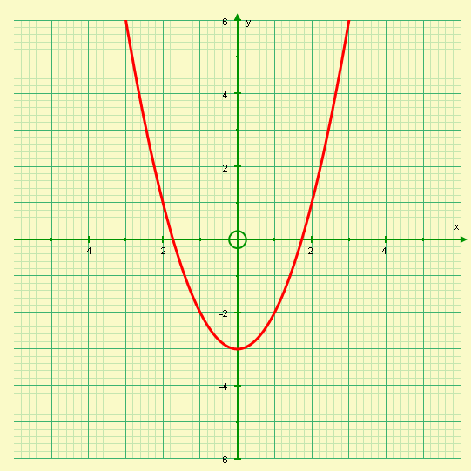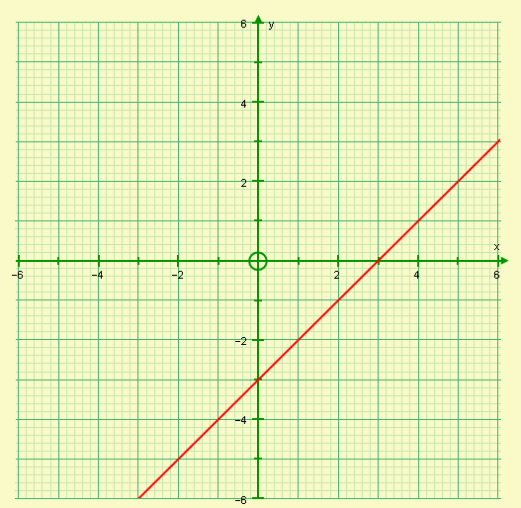
❶
❶
❶
Equation: y = x² - 3 Equation: x + y = -3
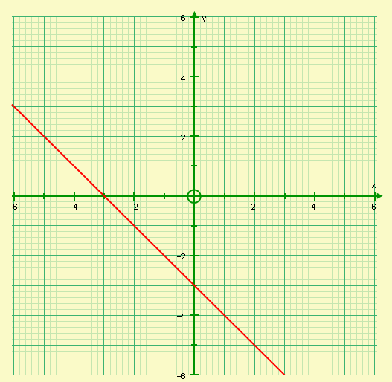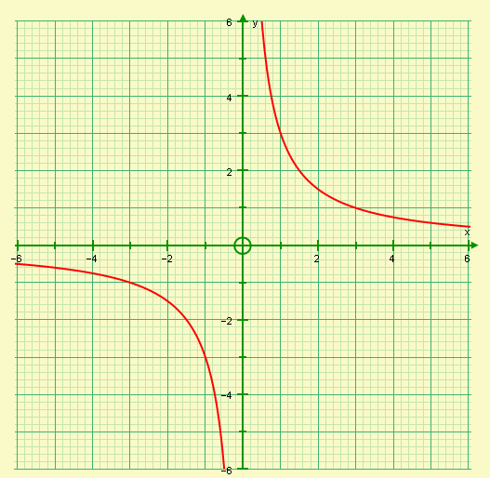
❶
Equation: y = -3 – x Equation: $y=\frac{3}{x}$
❶
❶
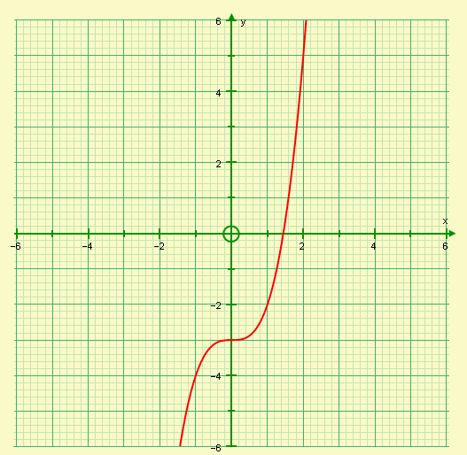
❶
Equation: y = x³ - 3 (6)

  - Solve 4x – 5 7 – 2x
❶
6x – 5 7 ( + 2x)

6x 12 ( + 5)
❶
x 2 ( ÷ 6 )
(2)

Show your answer on the number line below:

❶
❶
-4 -3 -2 -1 0 1 2 3 4 5

(2)

- a) On the axes below, mark the region R that satisfies the inequalities:

x < 2 y ≥ 1 y ≤ x + 3 x + y < 4

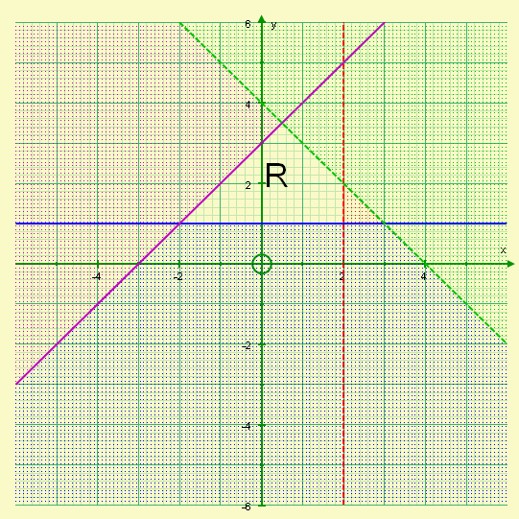
Subtract ❶ for the region not labelled R
Subtract ❶ for the lines not labelled

❷
❷

❶
❶
y=x+3
y=1
x=2
x+y=4

(6)

- Write down the integer co-ordinate pairs that lie within R
(-2,1) (-1,1) (0,1) (1,1) (1,2) (0,2) (-1,2) (0,3) (2)
❶ for 4 correct
❷ all 8 correct

- a) Complete the table of values for y = x³ + 3x² – 3.

X | -3 | -2 | -1 | 0 | 1
y | -3 | 1 | -1 | -3 | 1
(3)
❶
❶
❶

- Draw the graph of y = x³ + 3x² – 3

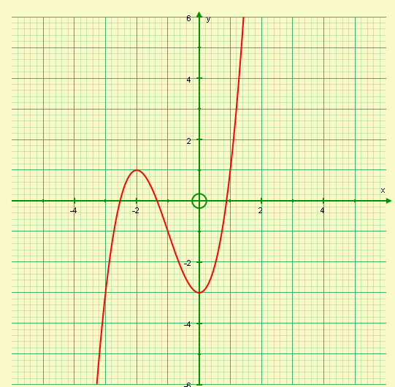
y=0
y=4
❶ points plotted correctly
❷ Smooth curve

(3)

- Using your graph, or otherwise, solve:
- x³ + 3x² – 3 = 0
x = 1·9 (± 0·1), -1·3 (± 0·1), -2·5 (± 0·1)
❶
❶
❶

ii) x³ + 3x² – 3 = 4

x = 1·3 (± 0·1)
❶
(4)
13. Make t the subject of the equation in the following:
❶
a) $v=\frac{t}{2}+s$ $\begin{aligned}v−s=\frac{t}{2} \\ 2(v−s)=t\end{aligned}$
❶

(2)
❶
b) $R=\sqrt{\frac{t}{b}}$ $\begin{aligned}R^{2}=\frac{t}{b} \\ {\text{bR}}^{2}=t\end{aligned}$
❶
(2)

  - Factorise completely:

- 3pq + 2p² ii) 4st – 14t³
❶
❶
❶
❶
❶

= p( 3q + 2p) = 2t(2s – 7t²)
❶
❶

(7)
15. Factorise completely:

- x² + 5x + 6 iv) p² - 9p + 20

= (x + 3)(x + 2) = (p – 5)(p – 4)

    - x² + 2x – 8 v) t² - 49
For each question
❶ for correct variables and format (x )(x )
❶ for one correct number
❶ for the other correct number

= (x + 4)(x - 2) = (t + 7)(t - 7)

    - y² - y – 12

= (y - 4)(y + 3)

(15)

      - a) Factorise x² - y²
❶

= (x + y)(x - y)
(2)
❶

b) Hence, or otherwise, evaluate:

53² - 47²
❶
= (53 + 47)(53 - 47)
= (100)(6)
❶
= 600
(2)
❶
❶
      - Simplify:
❶
❶
a) $\frac{3(x+1)^{2}}{x+1}$ = 3(x + 1) b) $\frac{x^{2}+5x+4}{x+1}$$=$$\frac{(x+4)(x+1)}{x+1}$= x + 4

(1) (3)

18. Solve x² + 13x + 12 = 0
❶
❶
(x + 12)( x + 1) = 0

x + 12 = 0 or x + 1 = 0
x = -12 or x = -1
❶
❶

(4)

19.
x + 5
x -2

- Write down an expression for the area, A, of the rectangle in terms of x.

( x + 5 )(x – 2)
❶
❶

(2)
- If A = 18cm², find the longest side of the rectangle.

❶
( x + 5 )(x – 2) = 18

x² + 5x – 2x – 10 = 18
❶
x² + 3x – 28 = 0
❶
(x + 7)( x – 4) = 0

x + 7 = 0 or x – 4 = 0
❶
x = -7 (not possible) or x = 4
❶
Longest side = x + 5 = 4 + 5 = 9cm

(5)

Did you ‘Make the Grade’?
Skill | Qu | ☺ | ☹
I can simplify involving indices expressions | 1
I can expand two linear brackets | 2
I can expand and simplify two linear brackets | 2
I can solve linear equations involving fractions | 3
I can solve simple simultaneous equations algebraically | 4a,b
I can solve more complex simultaneous equations algebraically | 4c,d
I can draw the graph of a linear equation | 5a, 9,11a
I can solve simultaneous equations graphically | 5b
I can interpret the equation of a straight line, y=mx+c | 6
I can find the equation of a straight line y=mx+c | 7,8
I can identify linear, quadratic, cubic and reciprocal graphs | 9
I can solve inequalities with unknowns on both sides | 10
I can solve inequalities graphically | 11
I can complete tables of values and draw graphs of cubics | 12a,b
I can solve cubic equations graphically | 12c
I can change the subject of harder fomulae | 13
I can factorise simple expressions | 14
I can factorise quadratics | 15i - iv
I can identify, factorise and use the difference of two squares | 15v, 16a,b
I can use factorizing to simplify algebraic fraction | 17
I can solve quadratic equations | 18
I can form and solve quadratic equations | 19

☺ Yippee!! - I got all the questions correct.
☹ I made mistakes and need to practise this topic more.

Top 3 topics I need to revise are

If your score is:
100 - 144 - Well done. You are working at grade B with your algebra skills.
50 - 99 - Promising work – make sure you ask for help and revise the topics that you had difficulty with. You can still get that B!!!
0 – 49 - Serious revision and help is needed if you are going to get
that B. Sort it out now. Don’t wait any longer

