MAKE THE GRADE

ALGEBRA

- Write down the nth term for the sequence 4, 10, 16, 22, …

(2)

- Write down the nth term for the following sequence:

1 3, 2 4, 3 5, 4 6, …

(2)

- Simplify the following:

a) p³ p²

b) 2t² 5t⁴

c) b⁷
b³

d) 24k⁶
3k²

e) 5h⁴ 4h²
2h³

f) (y³)²

(11)

- Expand y(y³ - 6)

(2)

5.
a) Simplify 3(x + 4) + 2(x +3)

(4)

b) Simplify 5(y + 3) – 4(y – 6)

(4)

6. Make x the subject of the y = 3x -6

(2)

7. Solve:

a) - 5 = 30

(2)

b) = 2

(2)

c) 5x + 22 = 2( x – 4)

x + 5
(3)
8.
Diagram not drawn to scale
x
x

x - 2

The perimeter of the trapezium is 13cm. Calculate the longest side.

(4)
9. Find the value of the smallest angle.
x
x+20º
120º
2x+60º
Diagram not drawn to scale

(3)
10. Solve 4x – 5 7.

(2)

Show your answer on the number line below:

(2)

11. n is an integer. Write down the possible values for n if:

-4 2n 5

(4)

12.

a) Complete the table of values for y = 2x² + 2x - 3.

x | -2 | -1 | 0 | 1 | 2
y |  | -3 |  |  | 9
(3)
b) Draw the graph of y = 2x² + 2x - 3
y

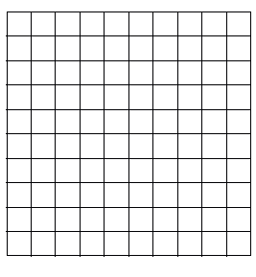
x
(2)

c) Draw the line y = -1 on the graph.
(1)
d) Hence, or otherwise, solve 2x² + 2x – 3 = -1

(2)

13. Hannah likes to feed the ducks at her local park. She leaves the house at 11.00a.m. The distance time graph shows her journey:

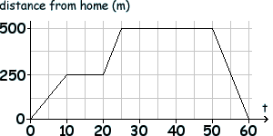
(min)

- What is Hannah’s average speed for the whole journey?

(3)
Assess your knowledge

Skill | Qu | ☺ | ☹
I can find the nth term of a linear sequence | 1
I can spot a pattern and find the nth term of a sequence | 2
I can use the rules of indices | 3
I can expand a term over a bracket | 4
I can expand and simplify an expression involving brackets | 5
I can change the subject of a formulae | 6
I can solve linear equations with unknowns on one side | 7a,b
I can solve linear equations with unknowns on both sides | 7c
I can construct and solve linear equations | 8, 9
I can solve linear inequalities | 10, 11
I can complete tables of values and draw graphs of quadratics | 12a, b
I can use graphs to solve equations | 12d
I can solve average speed problems | 13

☺ Yippee!! - I got all the questions correct.
☹ I made mistakes and need to practise this topic more.

Top 3 topics I need to revise are

If your score is:

50 - 60 - Well done. You are definitely working at grade C with your algebra skills. Bring on the B !!!

30 - 49 - Promising work – make sure you ask for help and revise the topics that you had difficulty with. You can still get that C !!!

0 – 30 - Serious revision and help is needed if you are going to get
that C. Sort it out now. Don’t wait any longer

