MAKE THE GRADE
ALGEBRA

- Write down the first three terms of the sequence described by the nth term n² - 3.

(3)

- A function machine inputs a number, n, multiplies it by 3 and then subtracts 6. What is the output for n=2?

(1)

- P = F(B -1) . Calculate the value of P when B = -5 and F = 20.
12

(2)

- a) Write down an expression for the total cost in pence of x chocolate bars at 80p and y ice creams at 75p each.

(2)
b) Write down a formula for the total cost, C, in pence.

(1)

- Sam buys t spiderman toys at 60p and 3 at £1.20. The total cost is £6.

  - Construct an equation.

(3)

  - Solve the equation to find the value of t.

(2)

6.
x
x + 5

- Write down an expression for the perimeter,P, of the rectangle in terms of x.

(2)

- If the P = 30cm, find the longest side of the rectangle.

(3)

7. Find the value of the largest angle.
x
x+20º
120º
2x+60º
Diagram not drawn to scale

(4)

8. Simplify:

a) 5a + 2b – 3a + b

(2)
b) p² + p² + p²

(2)
9.Expand 3(x – 4)

(2)
10. Factorise completely:

- 5a – 20

(2)

- p² - 5p

(2)

11. Solve:

a) 2x – 4 = 14

(2)
b) + 3 = 18

(2)

c) 4(3x + 2) = 44

(3)

d) 5x + 3 = 13 + 3x

(3)

12. At the point H, the graph of y = x + 6 crosses y = 4. Find the co-ordinates of H.

(3)

13.

a) Complete the table of values for y = x² + 3.

x | -2 | -1 | 0 | 1 | 2
y | 7 |  |  | 4
(3)
b) Draw the graph of y = x² + 3
y

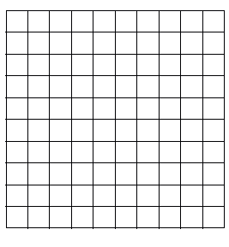
x
(2)
14. Draw the graph of y = 2x – 4.
y

x
(2)

12. Hannah likes to feed the ducks at her local park. She leaves the house at 11.00a.m. The distance time graph shows her journey:

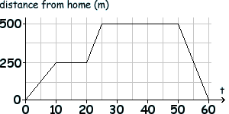
(min)

- On the way to the park, Hannah stops to have a snack. At what time did this occur?

(1)

- How long did Hannah stay at the park?

(1)
- What was Hannah’s average speed on the way home?

(3)

Assess your knowledge

Skill | Qu | ☺ | ☹
I can generate terms of a sequence using the nth term | 1
I can substitute values into fomulae | 2,3
I know the difference between an expression and a formulae | 4
I can construct and solve linear equations | 5,6,7
I can collect like terms | 8
I can expand an integer over a bracket | 9
I can factorise expressions | 10
I can solve linear equations with unknowns on one side | 11a,b,c
I can solve linear equations with unknowns on both sides | 11d
I can solve distance/time graphs | 12
I can complete tables of values and plot points | 13
I can draw the graphs of linear equations | 14
I can solve linear graph problems | 15

☺ Yippee!! - I got all the questions correct.
☹ I made mistakes and need to practise this topic more.

Top 3 topics I need to revise are

If your score is:

47 - 58 - Well done. You are definitely working at grade D with your algebra skills. Bring on the C !!!

28 - 46 - Promising work – make sure you ask for help and revise the topics that you had difficulty with. You can still get that D !!!

0 – 27 - Serious revision and help is needed. Sort it out now.
Don’t wait any longer

