MAKE THE GRADE

HANDLING DATA

1. Using the Box and Whisker Plot, complete the table:

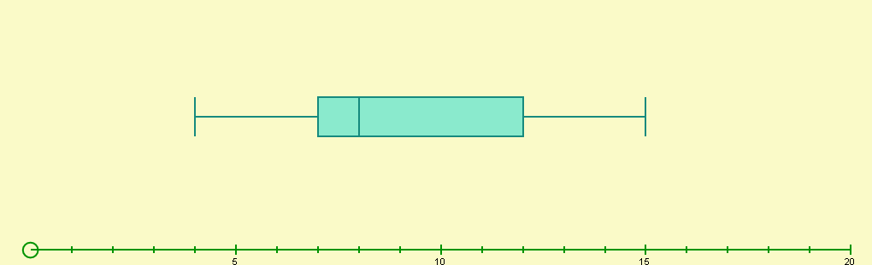

Minimum  value | Lower Quartile | Median | Interquartile  Range | Upper Quartile | Maximum  value | Range

(5)

2. Bob and Mary are driving instructors. The number of minor errors made by their students in the driving test are shown in the box and whisker plots below:

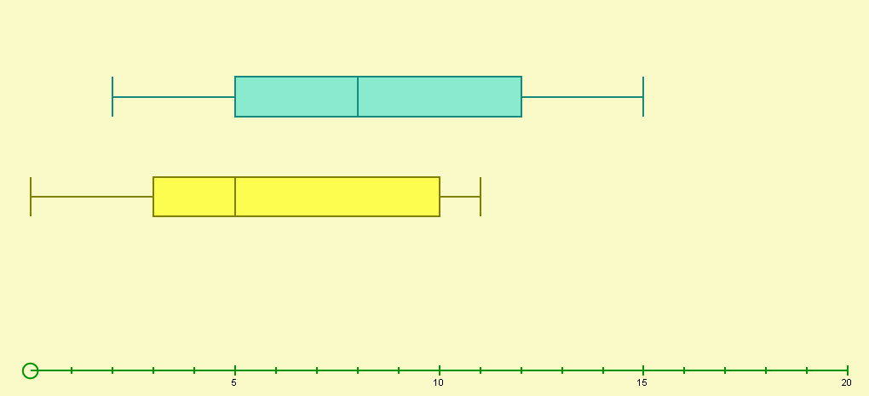
Bob
Mary

a) Who is the best driving instructor? Give reasons for your answer.

(3)
b) What percentage of Mary’s students had ten or more minor errors?
(1)
3. Match the frequency diagram with the correct Box and Whisker plot.
Complete the missing Box and whisker plot.
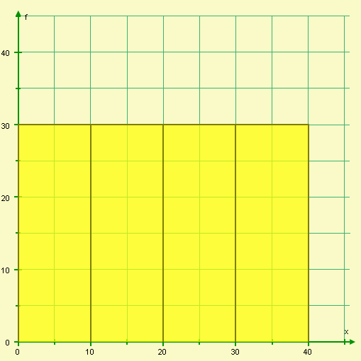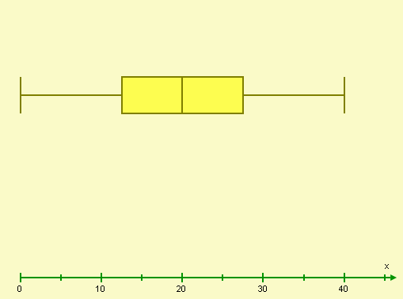
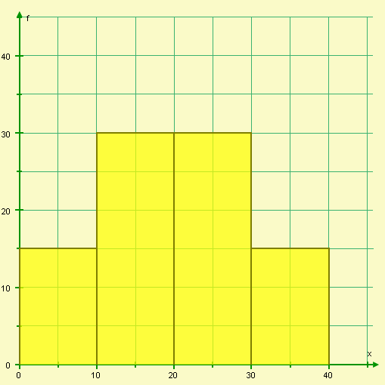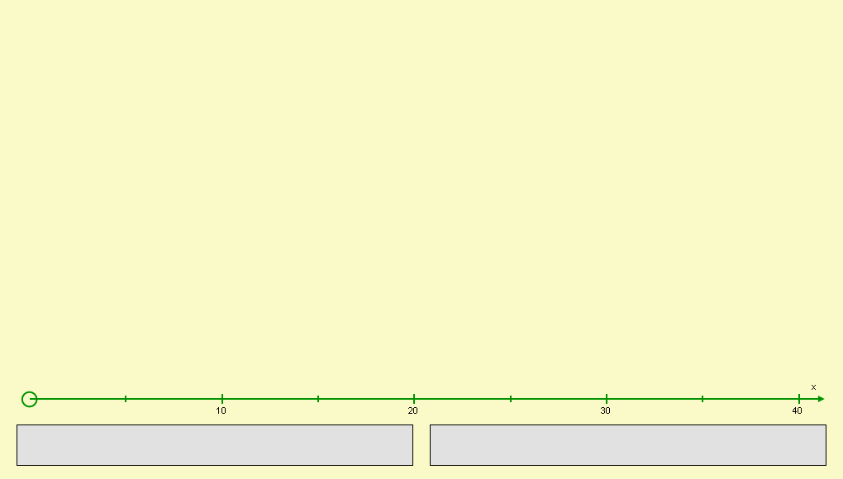
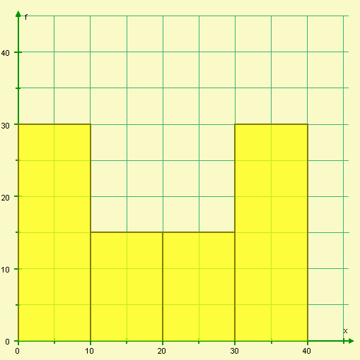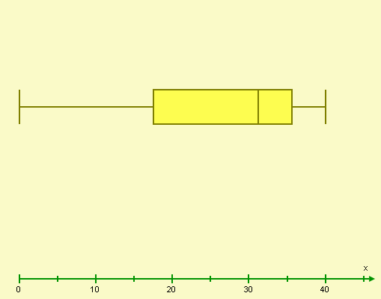

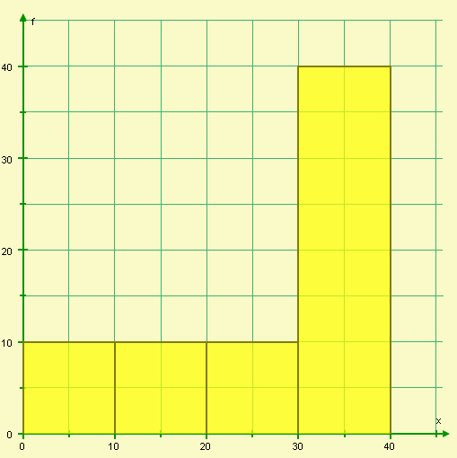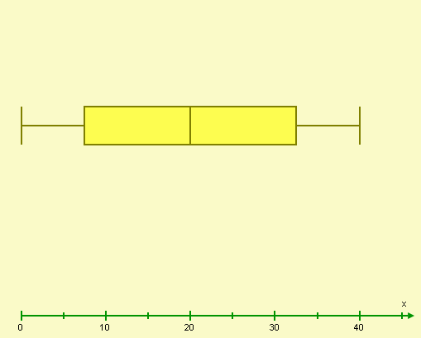
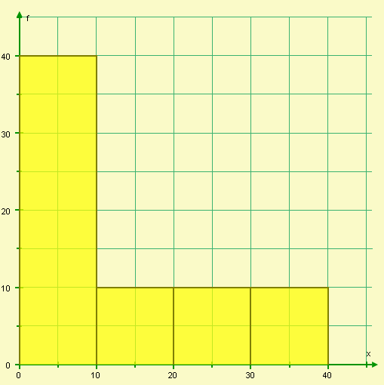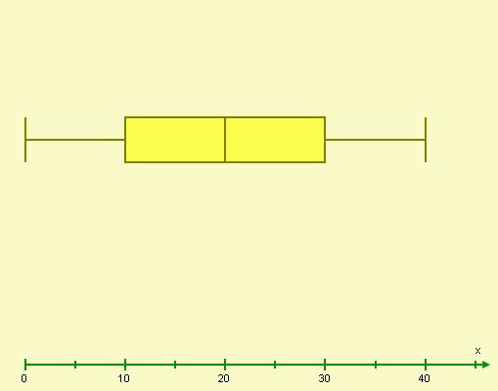
(7)

4. The table below shows the scores of students on the Non-calculator GCSE paper.
Score(x) | Frequency | Cumulative Frequency
0<x≤10 | 2
10<x≤20 | 3
20<x≤30 | 5
30<x≤40 | 15
40<x≤50 | 20
50<x≤60 | 15
60<x≤70 | 5
70<x≤80 | 8
80<x≤90 | 5
90<x≤100 | 2
- Complete the cumulative frequency column. (2)

b) Draw a cumulative frequency curve for the results (4)
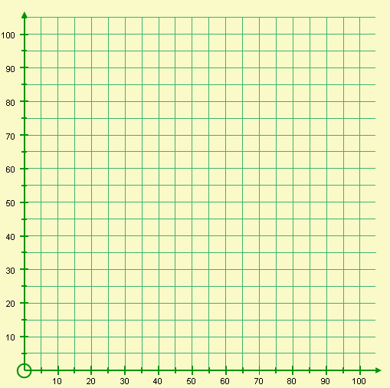

- Using your graph, find the median score for the Non-calculator paper.

(2)
- If the minimum score needed for a grade C is 52, using your graph, how many students achieved a grade C or higher?

(2)
  - 20% of the students achieved a grade B. Using your graph, what is the minimum score needed to achieve a grade B?

(2)

- The Box and whisker plot shows the scores of the students on the Calculator paper. Using your cumulative frequency curve, draw the box and whisker plot for the Non-calculator paper scores.

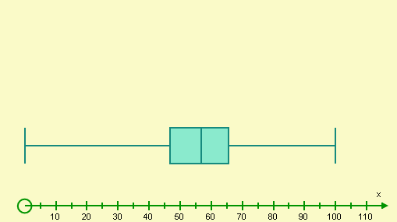

(4)

- Using the box and whisker plots, comment how students have preformed on the non-calculator and calculator papers.

(2)
5. Lance is drawing a cumulative frequency curve.
Length | Frequency
1<x≤2 | 0
2<x≤3 | 5
3<x≤4 | 15
4<x≤5 | 20
5<x≤6 | 25
6<x≤7 | 18
7<x≤8 | 10
8<x≤9 | 5
9<x≤10 | 3
10<x≤11 | 2
11<x≤12 | 1

Is he correct? Give at least two reasons for your answer.

(3)

6. Using the cumulative frequency curve below, complete the table:

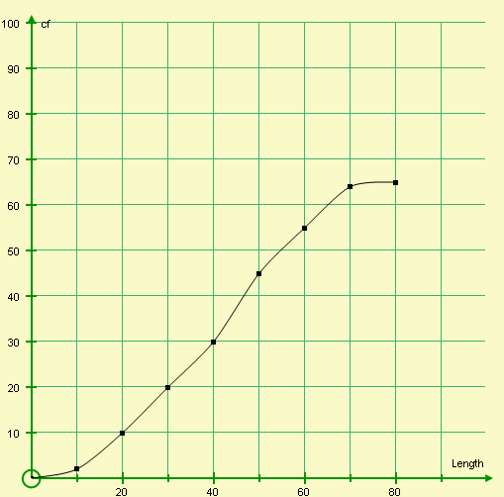
65

Length (L)
Frequency

(4)
7. The number of detentions Phil receives each week for poor behaviour are shown below:

Week | Detentions
1 | 3
2 | 4
3 | 5
4 | 1
5 | 2
6 | 3
7 | 5
8 | 1

- Calculate 4 point moving averages for this data.

(5)

b) Plot your 4 point moving averages on the time series below:

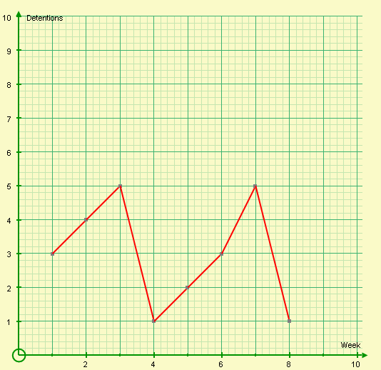

(2)
- Using your graph, comment on the trend of Phil’s behaviour

(1)
- Using the trend, estimate the number of detentions Phil will receive in Week 9.
(1)

8. Bob has a tube of ‘Millions’ (small coloured sweets). He is counting the sweets to see if there are millions if sweets in his packet. He records the colour of the first ten sweets:

Sweet | 1 | 2 | 3 | 4 | 5 | 6 | 7 | 8 | 9 | 10
Colour | Blue | Yellow | Blue | Yellow | Red | Blue | Blue | Blue | Red | Blue

Bob makes the following statements:
    - There are only blue, yellow and red sweets in my packet
    - There are more blue sweets than any other coloured sweet in my packet
    - The next sweet out will highly likely be blue or red

Do you agree with Bob’s statements? Explain your answers.

(6)

9 . Helen has two regular dice. She rolls each one 42 times and records the results.

Number | Die 1 frequency | Die 2 frequency
1 | 5 | 2
2 | 7 | 7
3 | 7 | 6
4 | 5 | 7
5 | 9 | 8
6 | 9 | 12

- Helen thinks one of her dice is biased. Do you agree? Give reasons for your answer.

(2)

10. The probability of a spinner landing on a two is 0∙2. If the spinner is spun 150 times, how many times would you estimate not to get a two?

(2)

11. Meryl has been revising hard using past papers and ‘Make the Grade’ assessments. She has worked out the probability of passing the calculator and non-calculator papers (getting at least a grade C). Complete the following probability tree diagram:
Pass $\frac{5}{7}$
Pass Pass

……………..

……………..

…………….. (5)

Pass …..
Fail ….

Pass ….
Fail $\frac{1}{4}$

What’s your probability of passing both papers?
DON’T LEAVE IT TO CHANCE!
Fail ….

CALCULATOR PAPER
NON- CALCULATOR PAPER

Did you ‘Make the Grade’ ?

Skill | Qu | ☺ | ☹
I can draw box and whisker plots | 1
I can compare two sets of data using box and whisker plots | 2,4g
I can match frequency diagrams with the correct box and whisker plot | 3
I can calculate the cumulative frequency | 4a,6
I can draw a cumulative frequency curve | 4b,5
I can use a cumulative frequency curve to find the median | 4c
I can use a cumulative frequency curve to find the upper and lower quartiles | 4f
I can use a cumulative frequency curve to find estimates | 4d-e
I can calculate moving averages | 7a
I can plot moving averages | 7b
I can use trends to make predictions | 7c-d
I can interpret relative frequencies | 8,9
I can use theoretical probabilities to make estimates | 10
I can complete probability tree diagrams correctly | 11

☺ Yippee!! - I got all the questions correct.
☹ I made mistakes and need to practise this topic more.

Top 3 topics I need to revise are

If your score is:

45 – 65 - Well done. You are working at grade B with your handling data skills.

21 – 44 - Promising work – make sure you ask for help and revise the topics that you had difficulty with. You can still get that B !!!

0 – 20 - Serious revision and help is needed. Sort it out now.
Don’t wait any longer

