MAKE THE GRADE
SHAPE, SPACE & MEASURESSHAPE, SPACE AND MEASURES
Questions
1 - 7

1.a) Calculate the area of the following sectors, leaving your
answer in terms of $π$:

(i)
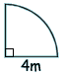

2cm

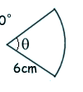
$$θ={\text{72}}^{∘}$$

(ii)

5cm

(iii)
6cm
45º

(6)

b) Find the length of the arc in each case, leaving your
answer in terms of $π$:

(6)
2.. a) Enlarge triangle ABC by a factor of -1·5, centre (0,0).
Label the image DEF.

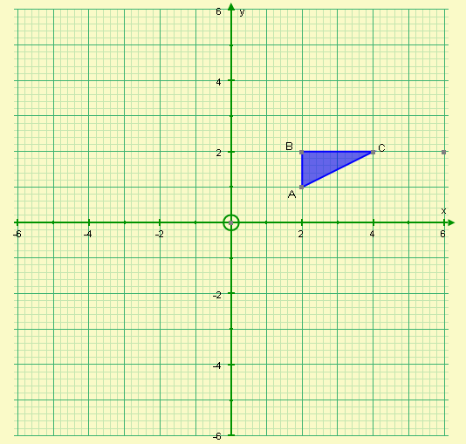

(3)
b) How many times bigger is the area of triangle DEF than the triangle of ABC?

(2)

3.
15cm
10cm

A

B

Cones A and B are similar.
The volume of cone A is 400cm³.
Find the volume of cone B.

(3)

4. In the following diagrams, are the two triangles congruent? Justify your answers in each case.
NOT TO SCALE

a)
B
D

35º
F
60º

35º
85º
A
C
E

D
b)
B

35º
60º
E
60º
4cm

35º
A
C
F
4cm

c)
B
D
4cm
60º
F
6cm
6cm

60º
A
C
4cm
E

(9)

5.
C
NOT TO SCALE

D

B

A
E

In the diagram above, BÂD = 60º and BÂE = 45º. Find, giving reasons for your answer:

a) $A\overset{}{D}B$

Reason:

b) $D\overset{}{C}B$

Reason:

c) $C\overset{}{D}A$

Reason:

(6)

- a) On the axes below, sketch the graphs of:

i) y = sinx

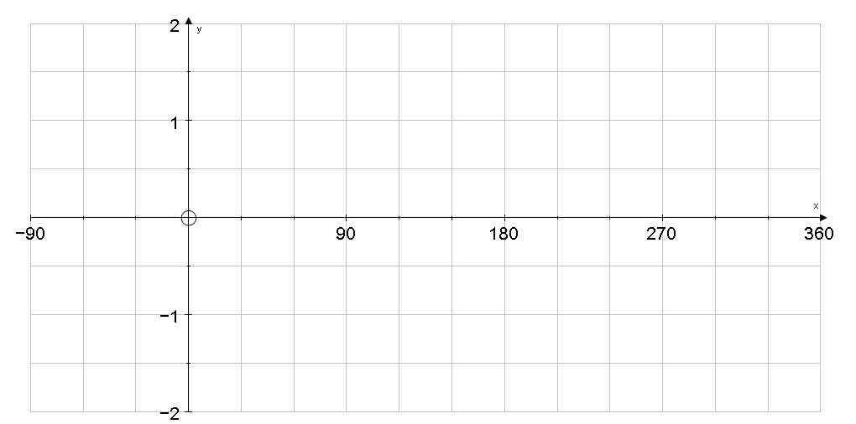

ii) y= tanx

b) i) On the axes below, sketch the graph of y= cosx

ii) Using your graph and cos60° = 0·5, solve the following equations in the range 0°<x<360°:

cosx = 0·5 cosx = -0·5

x = x =

(10)
- Find the value of x in the following triangles:
NOTE

Calculators are now allowed

NOT TO SCALE
i)
70º

x

30º
4cm

ii)

8cm

110º
40º
x

iii)

x
13cm

120º

5cm

(10)

- a) Find the value of x in the following triangles:
NOT TO SCALE

i)
x
12cm
4cm

14cm

ii)
x

12cm

50º
8cm

b) Find the possible values of y in the following triangles:

8cm
12cm

y
40º

(11)
9. Calculate the area of the following triangles:

a) An equilateral triangle of side 5cm

b)
40º
8cm

c)

7cm
6cm

30º

8cm

(6)

10. Find the area of the shaded region.

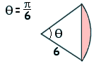
8cm

55º

(4)

11. Will Pam’s snooker cue of length 1.5m fit inside her cupboard?

1·2m

60cm
70cm

(5)

12. Calculate the distance between (1, -2, 5) and (-1, -3, 3)

(3)

- Chocolate balls are made by pouring molten chocolate into spherical moulds of diameter 4cm. How many can be made from 5 litres of molten chocolate?

(3)

- a) How much ice cream can be fill the following cone?
12cm

8cm

(2)
b) Find the curved surface area of the cone.

(3)

15. Which is greater – the total surface area of a hemisphere, radius 5cm or the total surface area of a cone, diameter 6cm, sloping edge 5cm?

(7)

16. Find the radius of a sphere with a volume of 500cm³.

(4)

Did you ‘Make the Grade’?
Skill | Qu | ☺ | ☹
I can calculate the area of sectors | 1a, (10)
I can calculate the length of circular arcs | 1b
I can enlarge shapes using negative scale factors | 2a
I understand the effect of enlargements on area and volumes | 2b, 3
I understand and use the conditions for congruent triangles | 4
I can solve circle problems using angle properties, in particular the Alternate Segment Theorem. | 5
I can sketch the graphs of sine, cosine and tangent | 6a, bi
I can solve simple trigonometrical equations | 6bii
I can solve problems using the sine rule | 7i,7ii, 8ii, 8iii
I can solve problems using the cosine rule | 7iii, 8i
I can find the area of any triangle | 9, (10)
I can solve Pythagoras problems in 2D and 3D | 11, 12,14b
I understand and use the formula for the volume of a sphere | 13,16
I understand and use the formula for the surface area of a sphere | 15
I understand and use the formula for the volume of a cone | 14a
I understand and use the formula for the surface area of a cone | 14b,15

☺ Yippee!! - I got all the questions correct.
☹ I made mistakes and need to practise this topic more.

Top 3 topics I need to revise are

If your score is:

76 - 103 - Well done. You are definitely working at grade A with your shape, space and measures skills. Bring on the A*!
40 – 75 - Promising work – make sure you ask for help and revise the topics that you had difficulty with. You can still get that A !!!
0 – 39 - Serious revision and help is needed if you are going to get that A. Sort it out now. Don’t wait any longer

