MAKE THE GRADE

SHAPE, SPACE & MEASURES
1. Rotate triangle EFG 90º clockwise about the origin. Label
y
the new triangle E’F’G’.
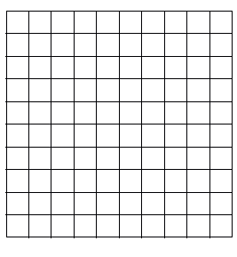
x
F
E
G
(3)

2. Reflect triangle PQR in the line y = -1. Label the image P’Q’R’.
y
x
R
Q
P
(3)
3. Describe the transformation of shape A to shape B.
y

x
B
A
(3)

4. Enlarge the triangle by a factor of 2 from centre P.
y
x
P
(3)
5. Find the missing angle in each diagram giving reasons for your answers:

a)
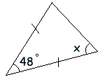 x =

Reasons:

(3)

b)
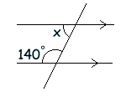x =

Reasons:

(2)

c)
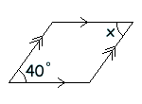x =
Reasons: (2)

d)
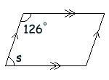 s =

Reasons:

(3)

e)
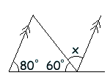x =

Reasons:

(3)

f)
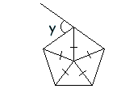y =

Reasons:

(3)

6. Calculate the interior angle of a regular hexagon

(3)

7. Calculate the exterior angle of a decagon

(2)
8. Draw a plane of symmetry on the solid:

(1)

9. Find the area and perimeter of the following shapes:

a)
5cm
4cm
3cm
Perimeter =

Area =

(4)

6cm

b)
6cm
10cm

Perimeter =

Area =

8cm

(5)

c)

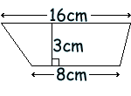
4cm
5cm
Perimeter =

Area =

(4)

10. Find the area and circumference of the circle given below:

20cm

(Take π = 3)

Area:

(3)

Circumference:

(3)

11. Convert 2∙4m² into cm²

(2)

12. Dorothy is painting her shed. 1 litre of paint covers 2m². How much paint does she need?

2m

3m

2m

(4)

13. You are looking at a solid from the side. Draw the front elevation and plan.
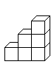
FRONT

(3)

Assess your knowledge

Skill | Qu | ☺ | ☹
I can transform using rotations and reflections | 1, 2
I can describe transformations fully | 3
I can transform using enlargements | 4
I can solve angle problems involving triangles and parallel lines | 5a-5e
I can solve angles involving polygons | 5f
I can calculate interior and exterior angles of regular polygons | 6,7
I can draw planes of symmetry | 8
I can solve perimeter and areas of triangles | 9a
I can solve perimeter and areas of shapes made of rectangles and triangles | 9b, 12
I can solve perimeter and areas of trapezia | 9c
I can find areas and circumferences of circles | 10
I can convert between units of area | 11
I can draw elevations and plans | 13

☺ Yippee!! - I got all the questions correct.
☹ I made mistakes and need to practise this topic more.

Top 3 topics I need to revise are

If your score is:

50 – 62 - Well done. You are definitely working at grade D with your shape and space skills. Bring on the C !!!

31 – 49 - Promising work – make sure you ask for help and revise the topics that you had difficulty with. You can still get that D !!!

0 – 30 - Serious revision and help is needed. Sort it out now.
Don’t wait any longer

